

# CTP 103 Course Project Part 1 Microsoft Excel – 100 points

##### Overview

In Part 1 of the course project, you will use Microsoft Excel to conduct an analysis of potential transfer colleges. The main objective of the assignment is to learn about Excel’s features, although the research part is beneficial to **most** students. If for some reason, you are not planning to transfer to another institution, you will still follow the same instructions, keeping in mind that you will still learn valuable skills in Excel.

An Excel file is called a “workbook”. Within the workbook, you can have multiple worksheets (also called spreadsheets) and charts on separate tabs in the workbook. Your workbook will be called **LastName_TransferColleges.xlsx**. You will be creating two worksheets and three charts, one embedded and two in separate sheets.

First things first

To learn how to use a program, it is best to use a systematic approach. The Goodwill Community Foundation (GCF®) has a website that provides free Microsoft Office Training. We will use their series of videos on [Excel 2016](http://www.gcflearnfree.org/excel2016/). Make sure that you review the Excel 2016 Tutorial document linked in the dropbox. It lists each video, the time (in minutes) and the training content for each video. If you are already familiar with Excel, make sure that you know how to do the skills listed in the document. There is an emphasis on what videos are most important for the project and which ones you should watch if are unfamiliar with Excel. To get the most out of it, you can download their practice workbook they provide for each video. Please do not attempt to do this exercise without going through the training first.

Follow the steps below to work through this assignment:

1. Choose six colleges you would like to research.
2. Set up the structure of the two worksheets (Financials and Information) using the instructions from Sections I and II below.
3. Visit [www.collegeboard.org](http://www.collegeboard.org) and <http://colleges.usnews.rankingsandreviews.com> to gather the data you need to enter into the spreadsheets.
4. Perform the tasks in these instructions to add formulas, functions, formatting, and charts.

As you work through the project below, you will see a link to a video that demonstrates that section. Click [here](https://www.youtube.com/playlist?list=PLe--K5RGf07LMlqdxgQ8ONDh62heYouLq) to link to all eight videos in a playlist. The duration of all videos combined is approximately 1 hour.

##### Section I – Setting up your Financials Worksheet

The first sheet in your workbook will be the Financials worksheet. You will enter data into the sheet that you find on the from [www.collegeboard.org](http://www.collegeboard.org) and <http://colleges.usnews.rankingsandreviews.com> on six transfer colleges to which you might transfer.

### Entering labels and naming a worksheet (#1)

Click [here](http://youtu.be/guSZLT97o8E?hd=1) to view the video for this section.

1. Open a blank workbook in Excel. Across the top insert the following labels in cells A1, B1, C1, etc. in the same order. You will notice that the text is cut off as you proceed typing the column labels. We will fix that in #2:
2. College
3. Tuition & Fees
4. Room & Board
5. Books & Supplies
6. Personal Expense
7. Transp Expense
8. Total 1-yr Cost
9. Total 2-yr Cost
10. Total 4-yr Cost
11. Avg Fin Aid Pkg
12. Cost Per Credit
13. App Fee
14. Over/Und Budget
15. AACC Savings
16. Select B2 (Tuition & Fees) through N1 (AACC Savings). In Excel, we call it a “range” and we indicate a range by the reference to the first cell, followed by a colon as follows: B1:N1. (See the video on cursor selection in the module.) Click on **Wrap Text** in the **Alignment** group of the **Home** **Tab**. Notice that it wraps the text into two rows (except L1).
17. With the range still selected, right-align the text (Alignment group on the Home tab.)
18. Select L1 and select the dropdown menu on the **Format** icon in the **Cells** group on the **Home** **Tab** and select **Column Width**. Type **7** in the column width box. Notice how “App Fee” is now on two lines like the other headings.
19. Select M1 and select the dropdown menu on the **Format** icon in the **Cells** group on the **Home** **Tab** and select **Column Width**. Type **9** in the column width box. Notice how “Over/Und Budget” is corrected. (Note: the video shows you how you can expand the column to make it fit properly. Either method is acceptable.



1. At the bottom of the worksheet, right-click on the tab **Sheet1** and select Rename. Type **Financials.**
2. Save the workbook as **LastName_TransferColleges.xlsx**.

### Entering data and formulas (#2)

Click [here](http://youtu.be/Iz3WOnfX3Jw?hd=1) to view the video for this section.

Now that the structure of the worksheet is set up, we can now begin to enter data from [www.collegeboard.org](http://www.collegeboard.org) and <http://colleges.usnews.rankingsandreviews.com>.

1. Enter the six college names and the following data for each of the colleges: Tuition & Fees (note: if you chose a college out of the state of Maryland, you must enter the out of state tuition and fees and not in-state.), Room & Board, Books & Supplies, Personal Expense, Transportation Expense, (skip the 1-yr, 2-yr, and 4-yr cost), Average Financial Aid Package, Cost Per Credit, and Application Fee. Don’t worry about formatting the numbers for now.
2. Enter the SUM function in G2 to add the all expenses for your first college using **AutoSum** button in the **Editing** group, on the **Home Tab**. Copy the formula to the other colleges using the fill handle.
3. To calculate the cost for two years, you will enter a formula. Always start a formula with an equal sign (=) and refer to the cell reference (instead of the value) in your formula. We want to multiply (using the asterisk sign *) the one-year cost by 2, so the formula would be **=G2*2**. Use the fill handle to copy for the other colleges.
4. To calculate the cost for four years, multiply the cost for two years times 2 or **=H2*2**. Use the fill handle to copy.
5. Save the workbook.

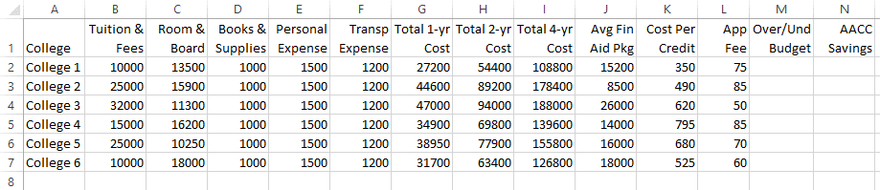Your spreadsheet should look like this:

### relative vs. absolute cell addressing (#3)

Click [here](http://somup.com/cbnuepPGk) to view the video for this section.

To calculate the savings a student realizes by attending AACC, we need to enter the current cost of attending AACC from the College Board site. No one can live on campus so other than Tuition & Fees you may use your own actual expenses or the ones on the College Board site.

1. Enter AACC in A10 and enter the expenses for each category. You can use copy and paste to paste the formulas for 1-year cost and 2-year cost. Note: you will have N/A for total 4-yr cost.
2. At this point it is very important that you understand the difference between absolute and relative cell addressing. Please watch the [associated video](https://youtu.be/iDg9s7BJ2m4) on the GCF Learn Free website if you have not done so already.
3. Enter a formula in N2 that calculates the savings you would realize by attending AACC for two years. Make sure that you use an absolute cell address for the 2-yr cost of attending AACC (=H7-$H$15). The dollar signs indicate an “absolute” cell reference which “anchors” the reference (in this case the Total 2-yr cost of attending AACC) and allows you to copy the formula so the calculation is correct.
4. Now that you have all the numbers, functions, and formulas in the spreadsheet, we are now going to view the spreadsheet with the formulas showing. Click on the **Show Formulas** in the **Formula Auditing** group on the **Formulas Tab**. When you click Show **Formulas** again, the spreadsheet goes back to normal view. Before you do this, there is no way to ascertain whether the numbers are values or formulas, or functions. This makes grading the spreadsheet easier.
5. Save the workbook.

##### Section II – Setting up your Information Spreadsheet

The Information worksheet is the second spreadsheet you will create. Other than your budget information, all the information is non-financial. You will also gather the information to enter into the spreadsheet from the college search websites. Follow the instructions below.

### Editing column width and number formatting (#4)

Click here to [view](http://youtu.be/JgcIScCtyWI?hd=1) the video for this section.

1. Click the plus sign (+) next to the Financials tab to add a new sheet. Right-click on the title **Sheet1** and rename the sheet **Information**. Your tabs should look like this:  
   
2. In A1 of the new Information sheet, type the label **Budget per year:**
3. Click on A4.
4. Click on the **Financials** sheet and select the College column label in A1 through the 6th college in A7 (in other words the range A1:A7 and choose Copy (or CTRL +C).
5. Click on the Information sheet and paste the contents in A4:A10. (Note: if you just click on A4 and paste, all the contents will be pasted.)
6. In B4:N4 type the following labels (Note: the number in parenthesis is the Column Width after your data is entered):

   2. City
   3. State
   4. Distance from Home
   5. # Undergrads
   6. % Graduate in 6 yrs
   7. Avg Age
   8. Student-Fac Ratio
   9. % Admitted
   10. % Transfers Admitted
   11. Min Cr to Apply as Trans Student
   12. Max Cr From 2-yr College
   13. Min Cr Must be Completed at Institution
   14. Date Trans App Due
7. With B4:N4 selected, wrap the text and alter the width of the columns so that they have a maximum of three lines. Because the column titles have significant variations in the amount to text, it requires that we manipulate the column width and row height to balance everything out. We will do this later. In the Alignment group, make sure that B4:N4 is vertically aligned on the bottom and horizontally centered. (See image to the right).
8. Auto Fit the row height of row 4.
9. The default numbering style in Excel is General. If the contents of the cells are all text or all numbers, the General formatting works. However, other times you need a different format, such as percentage and date. Enter the data into the sheet. You will need to designate the percentage columns using the Percentage format (0 decimal places), the Student Faculty Ratio as Text format, and the Application Deadline as Date format (using MM/DD format). The other columns can remain in the General format for now.
10. Save the workbook

Your spreadsheet should look like the spreadsheet below:

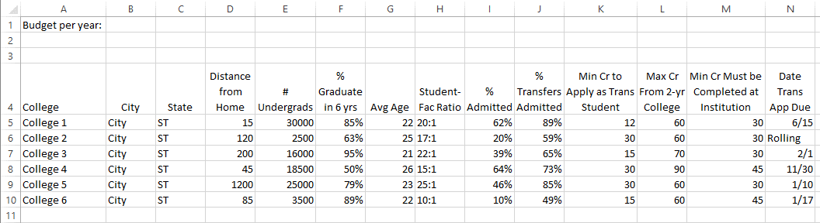

### 3D and absolute cell addressing (#5)

Click [here](http://youtu.be/tcdsHcpsxMc?hd=1) to view the video for this section.

So far, we have only entered formulas from the data on the same worksheet. Sometimes it is necessary to reference a cell on another worksheet in the workbook. Now that we have two sheets, we can try it out. Using the budget total on the Information sheet, we will calculate how each college annual expenses compare to the budget.

1. First, make sure you have entered an annual budget amount in B1 of the **Information** sheet.
2. Switch to the **Financials** sheet and click on M2 (the Over/Under Budget column).
3. Type an **equal sign (=)** to indicate we are starting a formula.
4. Click on the **Information** sheet tab.
5. Select **B1** (the amount of your budget). Note: because we are going to copy this formula, we need to make the cell reference absolute so after you have selected B1, **press the F4 key** (or you can add dollar signs as follows: =Information!$B$1) followed by a minus sign (-).
6. Switch to the **Financials** sheet and click on G2 (the Total 1-yr Cost of your first college), then press **Enter**. Your formula in M7 should be: **=Information!$B$1-Financials!G7**
7. Copy the formula down to **M12**.
8. Save the workbook.

##### Section III – Formatting the Spreadsheets

In this section, you will learn formatting skills to make the spreadsheets look professional.

### The average function and Formatting Data as a Table (#6)

Click here to [view](http://youtu.be/ITHAFuhktBE?hd=1) the video for this section.

In order give the data a professional look, you can format the data using Excel’s table formatting tool. We are going to format both tables in each spreadsheet.

1. Select the **Financials** worksheet. We want to make room to later add a title for the table, so we need to add 5 rows to the top of the spreadsheet.
2. Select the first 5 rows by clicking on the row numbers select **Insert** in the **Cells** group on the **Home Tab,** then **Insert Sheet Rows.**
3. Select cell **A13** and type **Average**. Right-align the contents of the cell.
4. Select the range **B13:N13** and click the dropdown arrow for **AutoSum** in the **Editing** group on the **Home Tab**. Select **Average**. Click in each cell in row 13 and notice the Average function formula in the formula bar for each cell. It has the same syntax as the Sum function, opening with an equal sign, then the function name AVERAGE, then the range of cells to be averaged in parenthesis: =AVERAGE(B7:B12).
5. Select the range A6:N13 (note: we are NOT including the data for AACC) and select the Format as a Table dropdown menu in the **Styles** group on the **Home Tab** and select any style. Notice that the formatting has changed the width of the columns and has made our titles on one line. We will fix that next.
6. First, make sure that column A width is “Best Fit”. Then select columns B-N. Select the **Format** dropdown menu and choose **Column Width** and type **8**. Column M will need to be expanded so that Over/Und is on the same line.
7. Select the cells in the Average row and select the **Cell Styles** dropdown from the **Styles** group on the **Home** **Tab**. Select the **Total** style under **Titles and Headings**.
8. Save the workbook.

Your table should look like this:

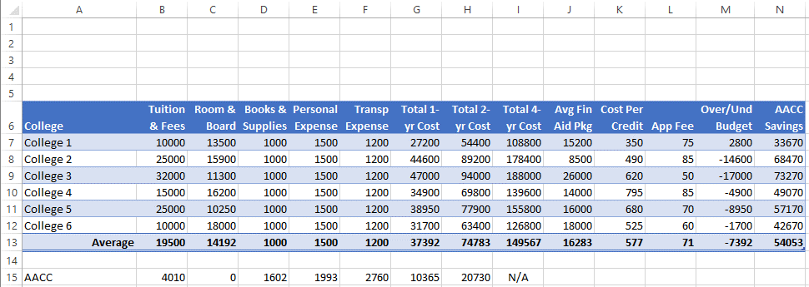

1. Select the **Information** sheet and format the data in the same way. Adjust the column widths for columns B-N to a column width of 10, then click on wrap text for the column titles and adjust the column widths so they that there are no more than three lines of text and that you can see text of the entire label. Center the titles for all but column A.
2. Center align the data in the following columns: B, C, F-M.
3. Type Average in A11 and right-align the text.
4. Add the AVERAGE function to all columns except Student-Faculty Ratio and Date. Select the text in row 11 and format it with the Total style.
5. Save your workbook.

Your table should look like this:

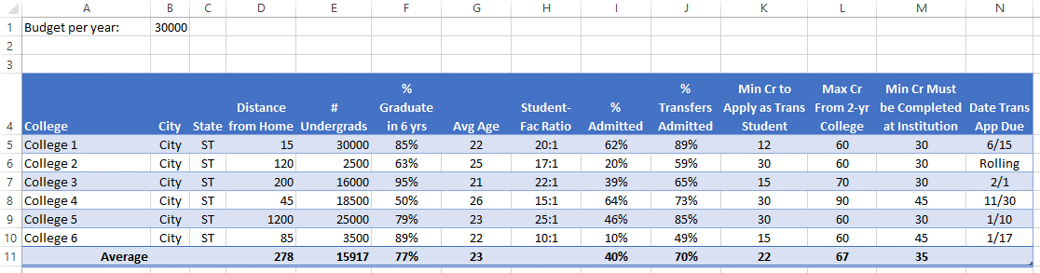

#### Number and conditional formatting and table titles – (#7)

Click [here](http://youtu.be/z0xiQXrVhpc?hd=1) to view the video for this section.

We will now put the finishing touches on the two tables in our workbook. Note: if you see ##### in a cell, it indicates that the cell width is too small to fit the contents. You can fix this problem by either reducing the number of decimals or resizing the column by dragging the column boundary or using Best Fit.

1. Click on the **Financials** tab and format the numbers in the table as follows:
   1. **B7:N13** – Currency (not the $ icon, which is the Accounting format which places the dollar sign at the far left of the cell), zero decimals, negative numbers in red with parenthesis.
   2. Conditional Formatting – **I7:I12** (Total 4-yr Cost) – Color Scales – Red, Yellow, Green (2nd column, 1st one) in **Styles** group on the **Home Tab**.
   3. B15:H15 (AACC) - Currency (not the $ icon, which is the Accounting format which places the dollar sign at the far left of the cell), zero decimals. (Note: the video does not show this.)
2. Click on the **Information** tab and format the numbers as follows:
   1. **D5:E11** – Number, with comma separator (you can use the comma icon since you will not need the red text to indicate a negative number).
   2. **B1** (Budget per year) – Currency (not the $ icon, which is the Accounting format which places the dollar sign at the far left of the cell), zero decimals.
3. Title for the **Information** table: Select **A3:N3**, click on the **Merge and Center** icon in the **Alignment** group on the **Home Tab** to merge the cells into one across the width of the table. Select either **Title** or **Heading 1** (your choice) under **Titles and Headings** in the **Cell Styles** dropdown menu in the **Styles** group on the **Home Tab.** You may change the formatting of the text, if you think it fits with the design of the table better.
4. Title for the **Financials** table: Switch to the **Financials** sheet. Select WordArt in the **Text** group on the **Insert** **Tab**. Select the WordArt of your choice (you will be able to edit your choice). Move the WordArt object in the blank space over the table. Expand the boundaries to spread across the table to center the WordArt across the table. Type **College Costs**.
5. You may edit the WordArt style by selecting the boundary of the WordArt to select it, then click on the Drawing Tools of the contextual ribbon, and select any of the Styles, Fills, Outlines, or Effect.
6. Save your workbook.

Your spreadsheets should look like this:

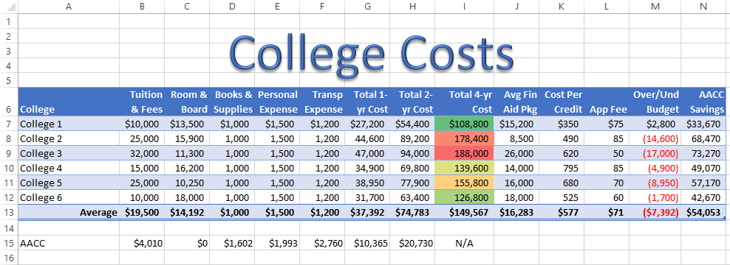

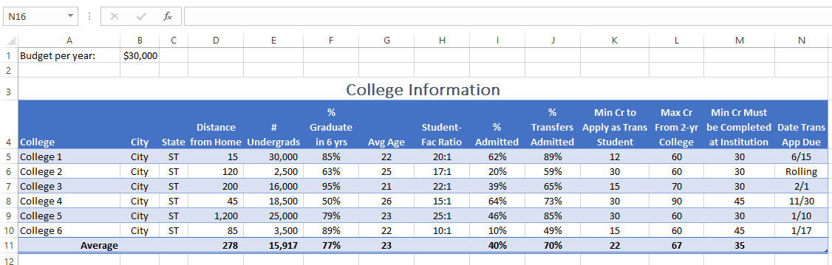

##### Section IV – Creating Charts (#8)

In this last section, you will create three charts based on the data in the Financials worksheet. One will be embedded in the worksheet itself and the other two will be created as separate sheets, thus creating new tabs at the bottom of the workbook

Click [here](http://youtu.be/buLYlr5_21s?hd=1) to view the video for this section.

###### Creating an Embedded 3-D column chart – AACC Savings

An **embedded chart** is one that is inserted on the same sheet as the table instead of as a separate sheet. In this embedded chart, you are going to show the comparison of the savings you would realize under each college scenario by attending AACC for two years.

1. Select **A7:A12** (Your six colleges) and hold down the CTRL key and select **N7:N12**. You use the CTRL key to select noncontiguous data. You have selected the data that is needed to create the chart.
2. 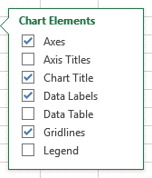In the **Charts** group on the **Insert Tab**, select the dropdown arrow on the icon for **Insert Column or Bar Chart** (the top-left icon to the right of **Recommended Charts**) and select **3D Clustered Column Chart**.
3. On the **Chart Tools** menu, choose whichever style you like.
4. After you have the chart selected, you will notice 3 icons in the upper right. Click on the top one (Chart Elements). Make sure the only checked elements are the ones indicated on the right (you may deselect Gridlines if you want.)
5. Notice that not all the data labels have a dollar sign. This is because we only formatted the table with the dollar sign on the first college. Using the format Painter, format the other numbers with a dollar sign.
6. Change the Chart Title to. **AACC Savings.**
7. Using the move handles, move the chart below the table and using the bottom right sizing handle expand the chart so it is approximately the size necessary to be between the B and M columns (you will have to move the chart).
8. Save the workbook.

###### Creating a 2-D column chart – Tuition Comparison

Sometimes you want to have the chart separate from the table so after you create the chart, you move it to a new sheet. You will create a 2-D column chart to just compare the Tuition and Fees of each college.

1. 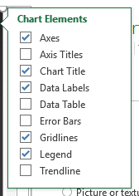In the Financials worksheet, select **A6:B12**. Notice that because the data are contiguous, you do not need to hold down the CTRL key**.**
2. Insert a **2-D Column Chart** using the **Charts** group on the **Insert Tab**.
3. With the chart selected, click on **Move Chart** in the Location group of the **Chart Tools Tab**. Select **New Sheet** and name the chart **Tuition Comparison**.
4. Select **Change Chart Ty**pe in the **Type** group of the **Chart Tools Tab** and select the multi-color style. Notice how “Tuition & Fees” is now in the x-axis.
5. You may customize the chart however you like but when you are finished, select the Chart Elements icon (the “plus” sign in the upper right outside the chart) and make sure that the elements listed to the right are included.
6. Save the workbook.

###### Creating a 2-D Clustered Bar Chart chart– Total 4-Year Cost

The last chart for this exercise is creating a bar chart for the total 4-year cost for all six colleges.

1. In the Financials worksheet, select **A7:A12**, hold down the CTRL key and select **I7:I12** (Total 4-yr Cost).
2. 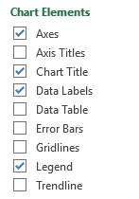Insert a **2-D Clustered Bar Chart** (you can also use a 3-D Clustered Bar Chart if you prefer) using the **Charts** group on the **Insert Tab**.
3. With the chart selected, click on **Move Chart** in the Location group of the **Chart Tools Tab**. Select **New Sheet** and name the chart **4-Year Cost**.
4. Format the chart however you like making sure that you have the chart elements listed to the right. The video demonstrates more formatting features. You may use any of the
5. Save the workbook.

Here is an example of what your charts may look like:

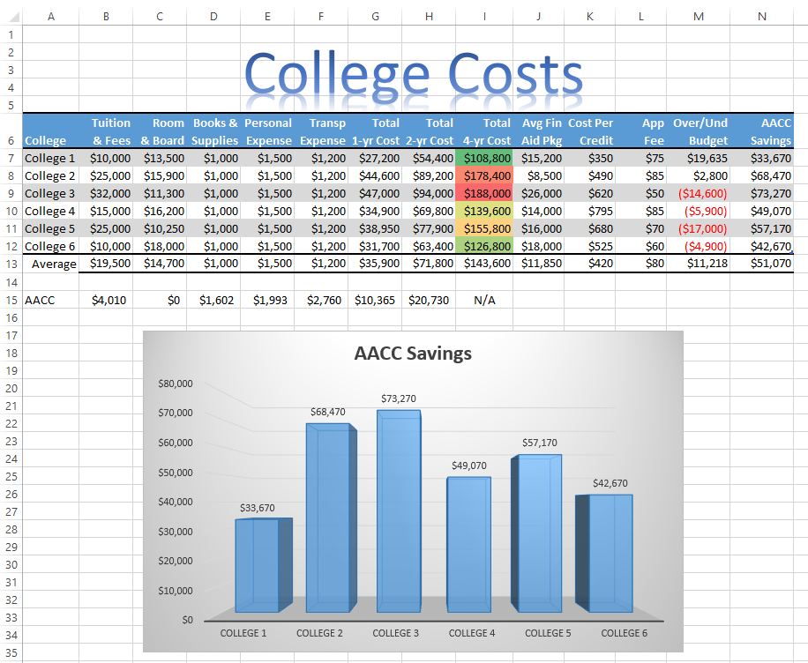Your AACC Savings chart is embedded in the Financials tab:

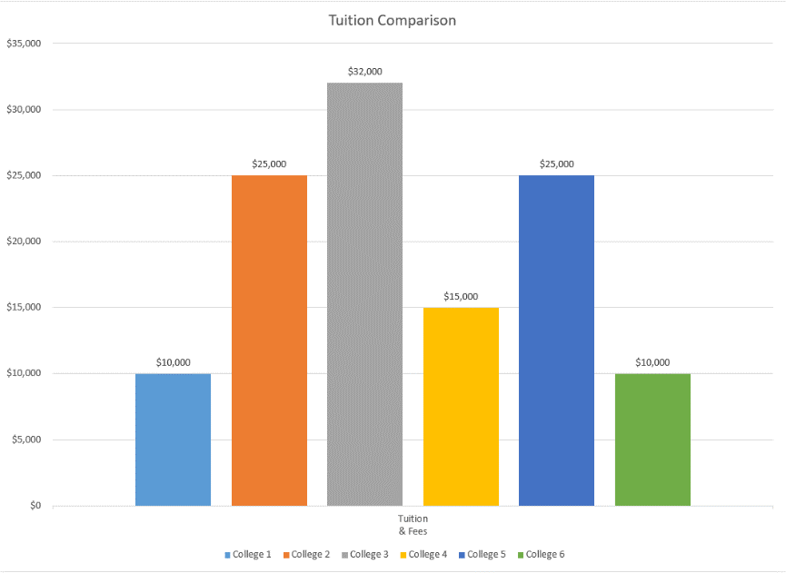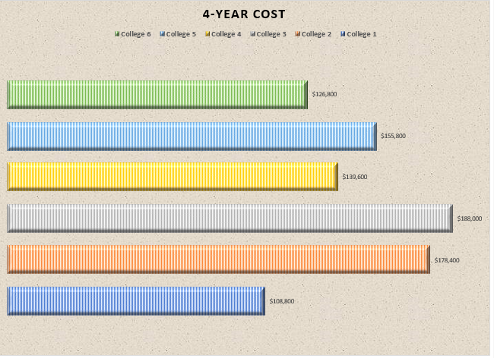Your 4-year Cost (bar chart) and Tuition Comparison (column chart) should be in their own separate sheets

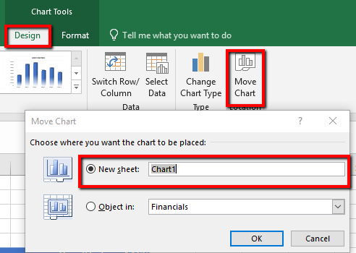Note: If you erroneously embedding one of these charts, you can move it to a sheet by clicking on the chart and going to the **Design** tab on the **Chart Tools** ribbon and selecting **Move Chart** – **New Sheet** and then name the sheet.

###### Formatting and rearranging the workbook tabs

You can format and rearrange the order of the sheet tabs in a workbook Follow the instructions below:

1. Move the Financials sheet to make it the first sheet.
2. Right-click on each of the four tabs and add a Tab Color to each (different colors) – See example below. The tabs MUST be in this order.  
   
3. Save the workbook.

##### Submission instructions

Submit the workbook you created in this lab – **LastName_TransferColleges.xlsx** (replacing LastName with YOUR last name) to the dropbox in Canvas by the due date.